**COMUNICATION AND LANGUAGE**

Continue to explore instrumental and environmental sounds

Talk Boost groups to develop listening and speaking skills

Talking about our stories

Retelling stories

**PHYSICAL DEVELOPMENT**

Using new tools safely ex. Chopsticks

Support all children with any physical support they may need.

Play cooperative games

Moving to music

Looking at ways to stay healthy

Practice cutting ex. When making sandwiches

Dough Gym

**PERSONAL, SOCIAL, EMOTIONAL DEVELOPMENT**

Explore feelings the feelings of others

Talking about fears, including those from stories

Discussing being responsible for our actions

What food do you enjoy?

Taking care of the environment around us.

**MATHEMATICS**

Providing children with daily reasons to count

Counting to 10 and beyond

Recognising numbers and ordering them

Practical indoor and outdoor activities that encourage counting and number recognition

Daily singing of number songs/rhymes

Practise using positional language

Practising problem-solving

**LITERACY**

Access to books and other printed materials

Making our own books and lists inspired by our key texts (authors and illustrators)

Making story maps

Retelling stories using story props

Topic activities to experiment with mark-making and writing.

Inviting parents to share stories and rhymes in home languages.

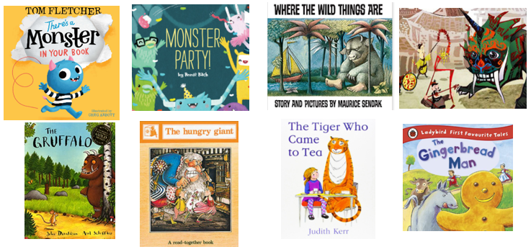

**UNDERSTANDING THE WORLD**

Exploring different animal groups, habitats and creatures in our environment (class pet)

Exploring different foods, we like to eat and experiment with new foods from around the world

Cooking and baking: what is healthy?

Exploring other places and talking about where we are from, places we’ve visited

Looking at things in our environment that help us grow

Caring for our environment.

Transport: how do we get around?

**EXPRESSIVE ARTS AND DESIGN**

Continue to provide children with a wide-range of opportunities to express media, colour and texture

Using various construction materials to build and balance

Role-play opportunities

Learning to move in different ways

Singing food songs