Over the past four weeks, year 4 have been learning the National Curriculum’s statutory spellings for their age group. It is expected that the children know these by the time they move into Year 5.
Before Easter, the children will be tested on a random list of these spellings, so we are sending them home this week for revision. Please support your child in practising their spellings, for this test and over Easter.
Many thanks,
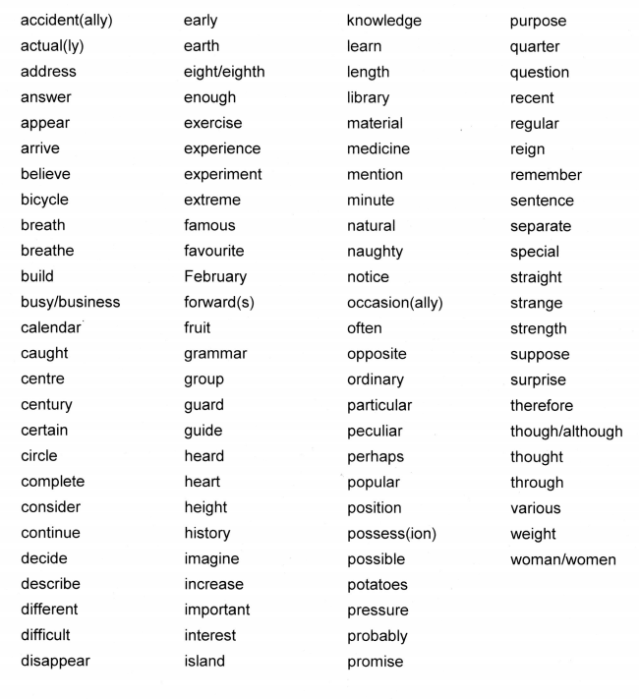
Year 4 teaching team

