Year 5 SRE (Sex and Relationships Education) Information for parents and carers
Our SRE unit is part of our PSHE (Personal, Social, Health and Economic Education) learning. It consists of 4 lessons and builds on the science unit Humans and Other Animals. The children have already learnt about the human life cycle, and as part of that, puberty. These units build and develop understanding. They are based on the Medway scheme of work.
“From September 2019 relationships education will be statutory in all schools at key stages 1 and 2. Education about relationships is covered through many aspects of the primary PSHE curriculum (and will go beyond the contents of these lesson plans). Schools should ensure their PSHE education programme therefore includes all elements of the new statutory guidance for relationships education, which will be published for consultation in Summer 2018. Elements of sex education that are not included in the statutory guidance will remain non-statutory in primary schools but in order to safeguard pupils effectively we strongly recommend that Medway schools provide a comprehensive programme of relationships and sex education (including these lessons) as an integral part of their PSHE provision. We therefore use the term relationships and sex education (RSE), rather than relationships education, to reflect this best practice approach.

These lessons contribute to the curriculum for PSHE education, as set out in the PSHE Association Programmeof Study for PSHE education. Signposted by the Department for Education, the PSHE Association’s Programme of Study outlines learning opportunities in three core themes: Health & Wellbeing, Relationships, and Living in the Wider World.
Primary schools must have regard to the Department for Education statutory guidance on preparing pupils for the physical and emotional changes of puberty before they experience them.” Medway
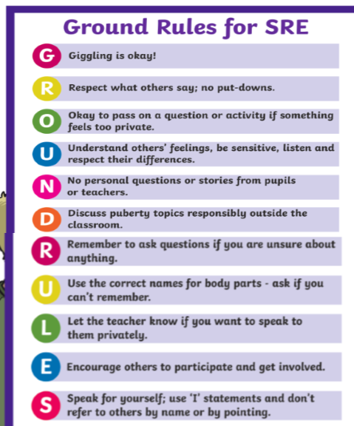
At the start (and at the beginning of each lesson) we set ground rules for the lesson:

Although the content is serious, the lessons are delivered in a fun and engaging way. Each lesson is in several parts, using a mix of whole class, paired, group and independent learning.

There are memory tests, quizzes, games, role plays (such as giving advice) and video clips.

Children can put questions anonymously in the “Ask It Basket” and we set aside times to answer. We promise to answer most questions, but reserve the right to suggest that a question is best answered by a parent, as it may be more appropriate. We also make it clear that in Year 6 they will learn more.

Examples from the lesson slides:

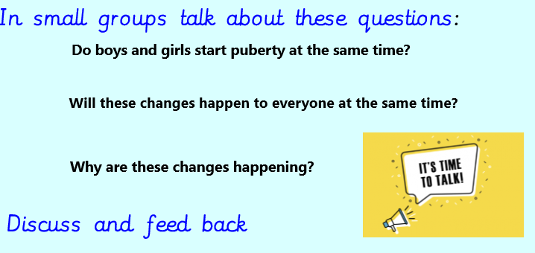

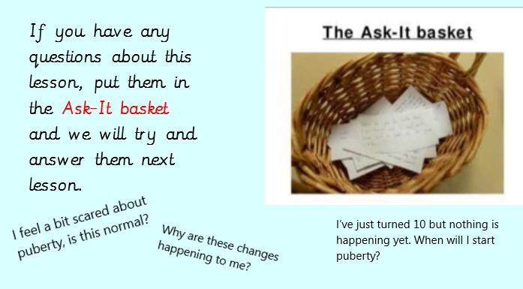

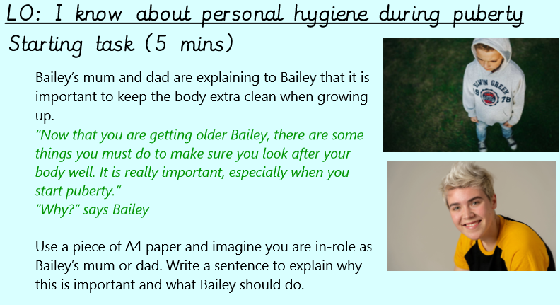

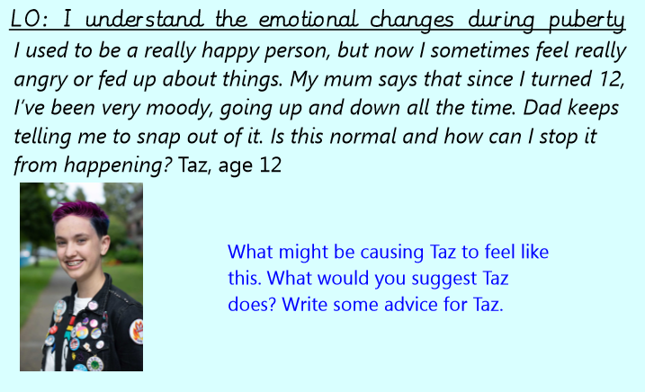

Example videos used:
Boy’s puberty: https://www.youtube.com/watch?v=RJtbLfJ_kRk
The menstrual cycle: https://www.youtube.com/watch?v=vXrQ_FhZmos

Book:
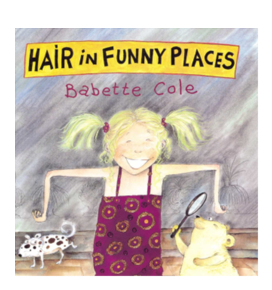

Lesson Content
Please note that this is the teacher guidance. Not everything will be discussed in detail and it will be led by the children and what is appropriate

Lesson 1 - PUBERTY: TIME TO CHANGE
The first lesson focuses on some of the external changes that happen to the body.
During the lesson, pupils will be recapping vocabulary for male and female body parts, including genitalia, previously learned in key stage one. Whilst you may highlight that children and adults sometimes use lots of different words for genitals, in this lesson you will use anatomic (scientifically correct) words. Explain to the pupils that some slang words (used to name genitalia) can be confusing and are sometimes even rude and
disrespectful. Therefore, it is important to only use the anatomic words in these sessions.
For the plenary/assessment activity pupils respond to some common questions about puberty that other children they age might ask. Make sure, during the feedback to this activity, you refer pupils to where they can find additional advice, this might include:
• Home: a parent or other trusted adult
• School: a teacher or other member of staff

Lesson 2 PUBERTY: MENSTRUATION AND WET DREAMS
The second lesson focuses in more detail on some of the external and internal changes that happen to the human body. This session is slightly longer than the others, taking approximately 90 minutes to deliver in total, with approximate timings for each activity provided to allow for flexibility. You may wish to cover it in two sessions—spending a whole session on female changes—and devoting another to male changes. The baseline
activity could also be carried out prior to the lesson, if time is short. However you approach this lesson, it is important that all pupils learn about both female and male changes.The lesson includes learning to name male and female genitals correctly.

The following gives an idea of what might be discussed and how:

Menstruation:
• Some girls start to menstruate (have their periods) at the age of 11 or 12, others start as late as 15 or as early as 8 or 9, but that’s all perfectly normal. If someone hasn’t started by 17, they should probably see a doctor as there may be other medical reasons.
• Some girls and women experience painful ‘cramps’ before and during their period. These cramps are usually a tight pain around the area of the uterus, but usually only for the first day of their period. Painkillers and exercise can help to relieve the pain. The breasts may swell slightly and feel tender. Some women and girls may also feel tense, moody or tearful just before or during their period. This is all perfectly normal!
• The blood usually comes out slowly and can be any amount, from a few tablespoonsful to half a cupful. The flow is usually heavier for the first couple of days of the period and gets lighter until it stops. Most periods last between three and five days but can be from about two to seven days.
• Sometimes your period doesn’t look or feel the way you expect. It might not even look like blood straight away. It might start with pinkish, reddish or brown discharge. This is all perfectly normal.

Erections: When a penis is not erect, blood flows in and out continuously, as it does in other areas of the body. When a male has an erection, the muscles that allow the blood to flow open up wide to allow more blood to be pumped in, while other muscles close—stopping the blood from leaving. This makes the penis become stiff and erect and it stands out from the body. This is called an erection. When the erection is over, the muscles relax and the blood flow returns, making the penis soft again. An erection can last from a few seconds to a
half-hour or more, and males can experience them any time from being a baby until they are old. Erections can happen at any time, and may happen unexpectedly. They usually happen when a male has sexy thoughts and feelings but can also happen when the bladder is full of urine, as this affects nerves at the base of the penis.
Sometimes males have erections for no reason—even when they don’t want to have them.

Producing sperm: The testicles make an incredible number of sperm—about one hundred million to three hundred million sperm each day. That’s about two thousand sperm every second! Once produced, the sperm travel through the epididymis, growing as they go. They travel through the vas deferens (the tube from the testicle that joins the urethra below the bladder) and mix with fluid: this mixture is called semen. Semen is a cloudy, whitish, sticky fluid. Sperm leave the body when a man ejaculates.

Ejaculation: To ejaculate means to suddenly ‘release’ or ‘to let go’, and ejaculation usually happens when the penis is erect. During ejaculation, semen squirts from the opening of the urethra at the end of the penis.

Wet dreams: Boys usually start having wet dreams when they start going through puberty. Wet dreams happen when a boy is having an exciting, pleasurable or sexy dream and ejaculates semen during his sleep. When he wakes up, there may be some sticky, wet semen on his sheets or pyjamas. Wet dreams are perfectly natural for boys; moreover, a boy’s first ejaculation often happens during a dream.

Lesson 3 -PUBERTY: PERSONAL HYGIENE
This lesson helps pupils to recognise the importance of personal hygiene during puberty, and to consider some of the questions young people may have about the physical changes at puberty.
During the session, you will want to include the following information:

Sanitary protection – pads and tampons: Advise pupils that it is best to have a discussion with a trusted grown-up about the best form of sanitary protection for them, although it’s probably best to start off using sanitary towels/panty pads. They come in all shapes and sizes, can be reusable or disposable, and are worn outside of the body. They attach onto a pair of pants and soak up the blood, then are disposed of, or washed (if using reusables) and a new/clean one used. It is important to change them regularly to avoid leaks and bad
odour. Stress the importance of hand washing and hygiene. Tampons are worn inside the body and absorb the blood in the vagina. They are made from cotton fibres pressed together, and also come in different sizes. Tampons are disposed of, and new ones should be used regularly. Again, stress the importance of hand washing and hygiene. Menstrual cups are used internally, in place of a tampon, to catch the blood. They can be emptied into the toilet, rinsed, and used again. Menstrual Sponges are also known as Sea Sponges or Sea Sponge Tampons. They are formed in the ocean, and have highly absorbent properties. Show examples of reusable protection such as cloth pads and menstrual cups as well as disposable towels and tampons, again, stress the importance of hand washing and hygiene.

Oily hair:Each strand of hair has its own sebaceous (oil) gland, which keeps the hair shiny and waterproof. But during puberty, when the sebaceous glands produce extra oil, it can make young people’s hair look oily and greasy. Washing hair regularly can help control oily hair. Use warm water and a small amount of shampoo to work up a lather. Scrubbing or rubbing too hard doesn’t get rid of oil any better and can irritate the scalp or damage the hair.

Skin and spots: Our sebaceous glands make more sebum (oil) when we start puberty: causing greasy hair and spots. The sebum can trap dirt, dead skin and germs or bacteria in our hair follicles—causing ‘blackheads’ and ‘whiteheads’. These spots, ‘zits’ or ‘pimples’ can appear on the face, where most sebaceous glands are. They can also appear on necks, chest, back or other places. Sometimes the bacteria that live on skin make
the spots inflamed and cause red lumps that we call acne. Spots are a usual and normal part of puberty, but can be upsetting and embarrassing. It is important to stress that almost everyone will get some spots at some point in their life, and that while some things such as a balanced diet can help to minimise them, nothing can guarantee someone will not get spots. The point should also be made that if someone does have spots, it does not mean that they have poor hygiene.

Sweat and body odour: Perspiration—or sweat—comes from sweat glands. During puberty, these glands not only become more active than before, but they also begin to secrete different chemicals into the sweat, causing a stronger smelling odour. Armpits might smell more than before. Feet and genitals might also have new smells. The best way to keep clean is to bathe or shower every day using a mild soap or shower gel and warm water. This will help wash away any bacteria that contribute to the smells. Wearing clean clothes, socks and underwear each day can also help to feel clean. Deodorants get rid of the odour of sweat by covering it up, and antiperspirants actually stop or dry up perspiration. They come in sticks, roll-ons, gels, sprays and creams, and are available at any pharmacy or supermarket.
Washing genitals (vulva): It is a good idea to avoid perfumed soaps, gels and antiseptics as these can affect the healthy balance of bacteria in the vagina, and cause irritation. Use plain, unperfumed soaps to wash the area around the vagina (the vulva) gently, every day. Some perfumed soaps can cause infections, irritation or itching—the vagina will clean itself inside your body with natural vaginal secretions (discharge).

Washing genitals (penis): Gently wash the penis with warm water and soap or shower gel each day when having a shower or bath. If the penis has a foreskin, it should be pulled back gently and washed underneath. If the foreskin is not washed underneath correctly, a cheesy-looking substance called smegma may begin to gather. Smegma is a natural lubricant that keeps the penis moist: it is found on the head of the penis and under the foreskin. If smegma builds up in the foreskin, it can start to smell and become a breeding ground for bacteria

Circumcision: All males are born with some loose skin covering the end of the penis, known as the foreskin. Some male babies have their foreskin removed shortly after they are born, by a doctor or a specially trained person. This process is called circumcision. Although a circumcised penis looks different from an uncircumcised penis, both work in the same way and equally well. Some circumcisions are performed for religious reasons, while others are for health reasons—to make it easier to keep the tip of the boy’s penis clean. An
uncircumcised penis can still be kept clean by pulling back the foreskin and gently washing the tip.

Lesson 4 -PUBERTY: EMOTIONS AND FEELINGS
This lesson focuses in more detail on some of the emotional changes that may take place during puberty and outlines some of the changes that may occur in friendships and other relationships. It teaches pupils where and how to get help and support.
Note on using the children’s story: Hair in Funny Places by Babette Cole
When you read the section ‘He soon began to take an interest in girls’, be sure to point out that anyone can experience that feeling about anyone; someone can have crushes on people of the same sex or the opposite sex, on people who are the same age, older or younger. Reiterate that having a crush on someone is perfectly natural.

Useful websites

• www.childline.org.uk
• www.nspcc.org.uk
• www.kidshealth.org/kid/
• www.bbc.co.uk/education/topics/z3xxsbk
• www.thinkuknow.co.uk/

Useful documents
• DfE statutory guidance on SRE: Sex and Relationships Guidance, DFE July 2000*
• Additional guidance, published by the PSHE Association, Sex Education Forum and Brook: Sex and Relationships Education (SRE) for the 21st Century, February 2014
https://www.nspcc.org.uk/globalassets/documents/advice-and-info/underwear-rule-children-guide-english.pdf

