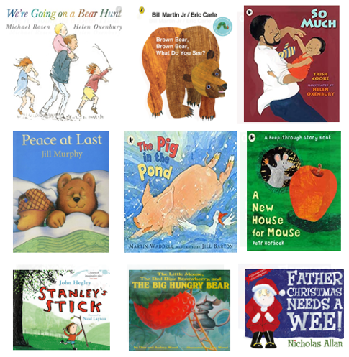
PHYSICAL DEVELOPMENT
Dough Gym
Gross-motor movements, ball skills and using equipment
Self-help skills: dressing and feeding ourselves
Communicating our needs (going to the toilet, hunger etc)
Support all children with any physical support they may need.
Using tools ex. Scissors/pencil
Moving to music
COMUNICATION AND LANGUAGE
Chat Time (small groups and as a whole-class activity)
Talk Boost groups to develop listening and speaking skills
Learning to follow simple instructions
Talking about themselves and their families
Answer simple inference questions about a story

PERSONAL, SOCIAL, EMOTIONAL DEVELOPMENT
Settling in
Taking turns and playing co-operatively
Making friends
Gaining confidence
Learning the Golden Rules and how to follow them

MATHEMATICS
Learning number rhymes
Number games in play
Repeating numbers in order
Counting with 1-1 correspondence
Counting abstract things such as jumps, claps etc.
Begin to use language of size
Interest in representing numbers
Interest in shape

UNDERSTANDING THE WORLD
Knows some of the things that make them special
Interest in lives of familiar people
Talk about similarities and differences in relation to family and friends
Special times for families and friends
Festivals and celebrations
Introducing our weekly cooking/baking sessions from around the world.
Knows information can be retrieved from computers
Skills in making real life objects.

LITERACY
Listening and joining in with stories in English and home languages.
Joining in with repeated refrains
Introducing environmental and instrumental sounds
Mark-making and exploring tools and paper
Distinguishing between different marks
Name writing

EXPRESSIVE ARTS AND DESIGN
Explores colour and how colour can be changed
Introduce children to new mixed media ex. glue, pens, paint, tape etc.
Enjoys joining in with dancing and games
Imaginative play
Sing familiar songs

