COMUNICATION AND LANGUAGE
Continue to explore instrumental and environmental sounds
Talk Boost groups to develop listening and speaking skills
Talking about our stories
Retelling stories

PHYSICAL DEVELOPMENT
Using new tools safely ex. Chopsticks
Support all children with any physical support they may need.
Play cooperative games
Moving to music
Looking at ways to stay healthy
Practice cutting ex. When making sandwiches
Dough Gym
PERSONAL, SOCIAL, EMOTIONAL DEVELOPMENT
Explore feelings the feelings of others
Talking about fears, including those from stories
Discussing being responsible for our actions
What food do you enjoy?
Taking care of the environment around us.

MATHEMATICS
Providing children with daily reasons to count
Counting to 10 and beyond
Recognising numbers and ordering them
Practical indoor and outdoor activities that encourage counting and number recognition
Daily singing of number songs/rhymes
Practise using positional language
Practising problem-solving

LITERACY
Access to books and other printed materials
Making our own books and lists inspired by our key texts (authors and illustrators)
Making story maps
Retelling stories using story props
Topic activities to experiment with mark-making and writing.
Inviting parents to share stories and rhymes in home languages.

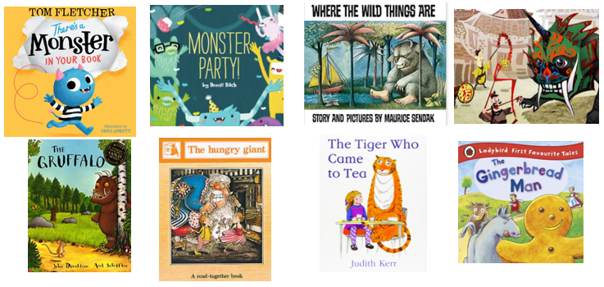
UNDERSTANDING THE WORLD
Exploring different animal groups, habitats and creatures in our environment (class pet)
Exploring different foods, we like to eat and experiment with new foods from around the world
Cooking and baking: what is healthy?
Exploring other places and talking about where we are from, places we’ve visited
Looking at things in our environment that help us grow
Caring for our environment.
Transport: how do we get around?

EXPRESSIVE ARTS AND DESIGN
Continue to provide children with a wide-range of opportunities to express media, colour and texture
Using various construction materials to build and balance
Role-play opportunities
Learning to move in different ways
Singing food songs

