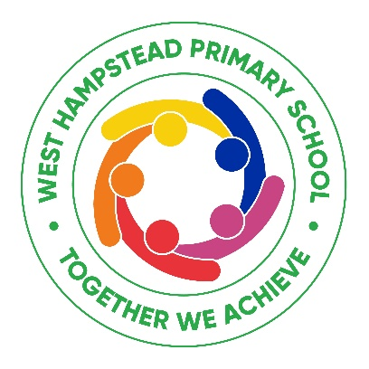

Dear Parent/Carer
We are delighted you have applied for a place in our Nursery for September 2027.
At West Hampstead Primary we firmly believe that nursery provides the best start to education and supports all the children (and parents!) to become involved in our community school, to build relationships and to become immersed in the learning journey. I am very pleased to let you know that the West Hampstead governors have agreed to maintain our full time nursery provision for the 2027 – 2028 academic year.
It would really help us if you could complete the attached forms and return them to us as soon as possible. We need some personal information about you and your child and to be able to determine how you will fund your Nursery place at West Hampstead, whether this is through eligibility for either the Government extended offer for the children of working parents or the Camden Enhanced Offer. An outline of all eligibility criteria is detailed below.
Information provided will be treated as confidential and individual details will not be shared.
Please complete the Nursery Application Form and Parent Declaration form which are available on our website or from the school office.
Please complete and return all forms to the school office.
All three and four year olds will remain entitled to 15 hours of free early education (15 hours a week for 38 weeks, up to the total of 570 hours). However there is a national offer of 30 hours’ free early education - an additional free 15 hours – but only for working parents who meet certain criteria. (see Nursery Appendix A)
More information on criteria and eligibility are available online at -
https://childcare-support.tax.service.gov.uk
We require all parents who qualify for the additional 15 hours free funding to apply to the HMRC using the online portal which can be accessed through Childcare Choices at ( see Nursery Appendix A):
https://www.childcarechoices.gov.uk
The Childcare Choices portal will take you through the application process. If you encounter any problems with the application process please direct your queries to the Childcare Service Customer centre on 0300 123 4097.
On completion of the application you will have a childcare service account. If you are eligible for 30 hours free funding you will be given an 11 digit ‘eligibility code’. You will need to provide us with the code and your national insurance number to allow us to claim the funding for your child. You must pass this information onto us by 26th June 2027 so that we are able to ensure that we receive the funding in time for your child’s start date in September 27.
If you think you do not meet the eligibility criteria as stated above for the 30 hours free government funding then please also complete the ‘Camden Enhanced Offer’ form online at www.camden.gov.uk/childcare.

This scheme is for Camden residents only and may provide additional funding for any child who does not receive the government offer (see Nursery Appendix). If you are eligible for this funding you will receive a confirmation letter from Camden. Again, we request that you pass this information onto us by 26th June 2027 so that we are able to ensure that we receive the funding in time for your child’s start date in September 27.
Yours faithfully
Sam Drake
Headteacher

