 |  | Reception  Autumn 1 Week 1&2

To support your child with their word reading, each week we will be sending home a list of the focus sounds/words that your child has been learning in school in addition to their reading books. Please spend time practising these sounds/words at home.

We have learnt the sounds:  s a t p i n m d | Write - Practise your letter formation:  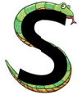 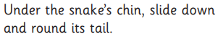 s s   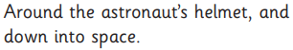 a a   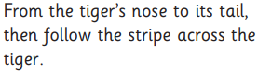 t t  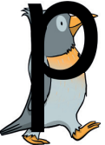 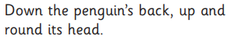p p   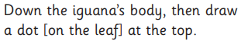 i i   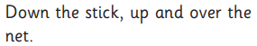n n  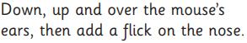m m  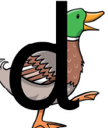 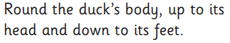d d
We have learnt to blend the words:
sat
sit
tip
nap
pan
man
map
mat
dip
  Scan this code using a phone or IPad to watch helpful videos and find downloadable resources linked to the sounds. |   Ask a grown up to read out each of the words to you. Can you hear the sounds and write them to spell each word?

