 |  | Reception  Autumn 1 Week 3

To support your child with their word reading, each week we will be sending home a list of the focus sounds/words that your child has been learning in school in addition to their reading books. Please spend time practising these sounds/words at home.

We have learnt the sounds:  g o c k | Write - Practise your letter formation:  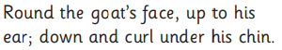 g g   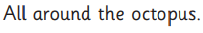 o o   c c  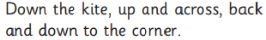 k k
We have learnt to blend the words:
man
mat
sad
pin
dig
dog
pot
nod
cog
got
kid
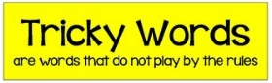
We learnt the tricky word:
is

  Scan this code using a phone or IPad to watch helpful videos and find downloadable resources linked to the sounds. |   Ask a grown up to read out each of the words to you. Can you hear the sounds and write them to spell each word?

