 |  | Reception  Autumn 1 Week 4

To support your child with their word reading, each week we will be sending home a list of the focus sounds/words that your child has been learning in school in addition to their reading books. Please spend time practising these sounds/words at home.

We have learnt the sounds:  ck e u r | Write - Practise your letter formation:  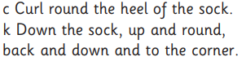  ck ck   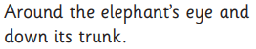e e  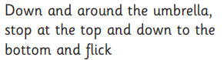u u  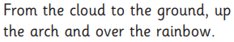 r r
We have learnt to blend the words:
sock
pick
top
set
get
ten
cup
mum
duck
pet

Our tricky words are:
is I

  Scan this code using a phone or IPad to watch helpful videos and find downloadable resources linked to the sounds. |   Ask a grown up to read out each of the words to you. Can you hear the sounds and write them to spell each word?
Please use https://www.phonicsplay.co.uk/ to further reinforce phonics at home. We have been learning phase 2. | Username: westhampstead  Password: phonics21

