 |  | Reception  Autumn 1 Week 5

To support your child with their word reading, each week we will be sending home a list of the focus sounds/words that your child has been learning in school in addition to their reading books. Please spend time practising these sounds/words at home.

We have learnt the sounds:  h b f l | Write - Practise your letter formation:  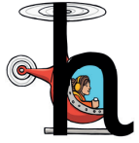h h  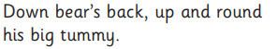b b  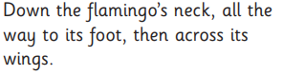f f   l l
We have learnt to blend the words:
red
hat
hug
big
muck
bat
fit
log
luck
rub
hot
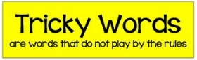
We have learnt the tricky words:
is I the

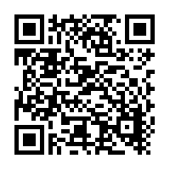  Scan this code using a phone or IPad to watch helpful videos and find downloadable resources linked to the sounds. |   Ask a grown up to read out each of the words to you. Can you hear the sounds and write them to spell each word?
Please use https://www.phonicsplay.co.uk/ to further reinforce phonics at home. We have been learning phase 2. | Username: westhampstead  Password: phonics21

