 |  | Reception  Autumn 2 Week 2

To support your child with their word reading, each week we will be sending home a list of the focus sounds/words that your child has been learning in school in addition to their reading books. Please spend time practising these sounds/words at home.

We have learnt the sounds:  v w x y | Write - Practise your letter formation:  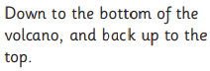 v v v  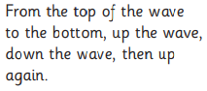 w w  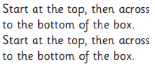 x x x  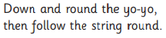 y y y y
We have learnt to blend the words:
van
vet
wet
wig
wag
fox
six
box
yes
yum
yap
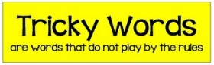
We learnt the tricky words:
and has his her

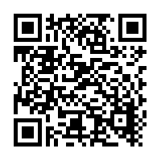  Scan this code using a phone or IPad to watch helpful videos and find downloadable resources linked to the sounds. |   Ask a grown up to read out each of the words to you. Can you hear the sounds and write them to spell each word?
Please use https://www.phonicsplay.co.uk/ to further reinforce phonics at home. We have been learning phase 2. | Username: westhampstead  Password: phonics21

