 |  | Reception  Autumn 2 Week 5

To support your child with their word reading, each week we will be sending home a list of the focus sounds/words that your child has been learning in school in addition to their reading books. Please spend time practising these sounds/words at home.

  We have reviewed all of the sounds learnt in the Autumn Term | Write - Practise your letter formation:  cups pots  ship bags  dogs rings  long nod  buzz mum  zip fish
We have practised blending these words:
ducks
ships
shuts
rings
shells
sings
ducks
long
chip
think
quick
mix

We learnt the tricky words:
we me be

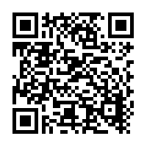  Scan this code using a phone or IPad to watch helpful videos and find downloadable resources linked to the sounds. |   Ask a grown up to read out each of the words to you. Can you hear the sounds and write them to spell each word?
Please use https://www.phonicsplay.co.uk/ to further reinforce phonics at home. We have been learning phase 2. | Username: westhampstead  Password: phonics21

