 |  | Reception  Autumn 2 Week 6

To support your child with their word reading, each week we will be sending home a list of the focus sounds/words that your child has been learning in school in addition to their reading books. Please spend time practising these sounds/words at home.

  We have reviewed all of the sounds learnt in the Autumn Term | Write - Practise your letter formation:  sock bed  ten top  hug fat  run cats  long duck  can fish
We have practised blending these words:
puff
mess
hill
quack
chop
wink
thud
bags
shells

We learnt the tricky words:

to we he the

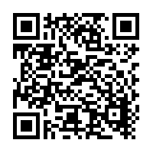  Scan this code using a phone or IPad to watch helpful videos and find downloadable resources linked to the sounds. |   Ask a grown up to read out each of the words to you. Can you hear the sounds and write them to spell each word?
Please use https://www.phonicsplay.co.uk/ to further reinforce phonics at home. We have been learning phase 2. | Username: westhampstead  Password: phonics21

