 |  | Reception  Spring 2 Week 1
To support your child with their word reading, each week we will be sending home a list of the focus sounds/words that your child has been learning in school in addition to their reading books. Please spend time practising these sounds/words at home.

We have revised the sounds:  ai ee igh oa oo ar or ur ow oi ear | Read each sentence: Support your child with sounding out if they need help.  The cat has a ribbon in its tail.  This duck got in the boat.
We have learnt to blend the words:
tail main
feel deep
right fight
load soap
food boot
hard bar
born sort
surf curl
foot took
down town
join coil
hear beard
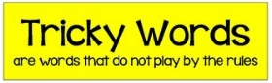
We revised the tricky words:
is as his has the I put pull full
  Scan this code using a phone or IPad to watch helpful videos and find downloadable resources linked to the sounds. |   Ask a grown up to read out each of the words to you. Can you hear the sounds and write them to spell each word?
Please use https://www.phonicsplay.co.uk/ to further reinforce phonics at home. We have been learning phase 2 and phase 3 | Username: westhampstead  Password: phonics21

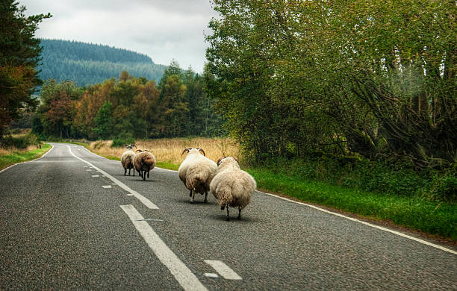

Challenge: Write down three things you can see.
Stretch: Can you write a sentence about the picture?

________________________________________________________________________________________________________________________________________

