 |  | Reception  Spring 2 Week 5
To support your child with their word reading, each week we will be sending home a list of the focus sounds/words that your child has been learning in school in addition to their reading books. Please spend time practising these sounds/words at home.

We have revised the sounds:  -s making a /z/ or /s/ sound  visit /z/  fights /s/  -es making a /z/ sound  torches | Read each sentence: Support your child with sounding out if they need help.  We had a visit to see the queen.  You need to put on coats and boots to go into the garden.
We have learnt to blend the words:
visit queens
chairs chains
poison fights
boots coats
cooks surfs
torches fishes
wishes foxes
boxes fizzes

We revised the tricky words:

they all by my are sure pure
  Scan this code using a phone or IPad to watch helpful videos and find downloadable resources linked to the sounds. |   Ask a grown up to read out each of the words to you. Can you hear the sounds and write them to spell each word?

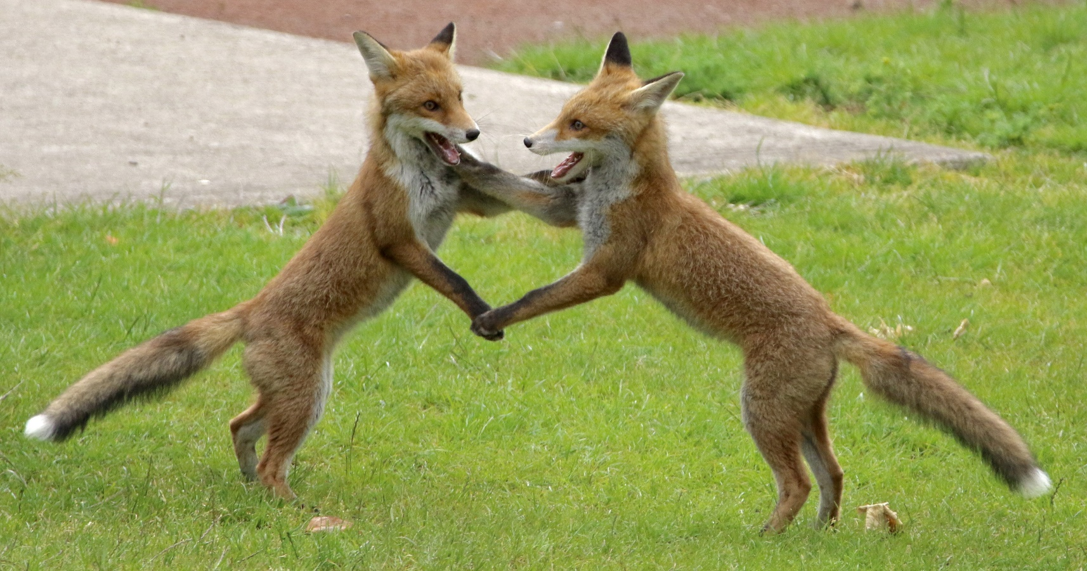

Challenge: Write down three things you can see.
Stretch: Can you write a sentence about the picture?

________________________________________________________________________________________________________________________________________

