The West Hampstead Curriculum - A Guide for Parents in Reception – 2021-22
Over the past few months, we have been working on developing and improving our ‘West Hampstead Curriculum’. This document shows you what children in Reception will be learning throughout the year and what your child will be learning in the Autumn term. You will receive more information later in the year.
Intent - The West Hampstead Curriculum is designed to:
- Teach our pupils to learn well
- Teach our pupils how to lead happy, healthy, constructive lives, in which they can aspire and experience success
- Ensure broad and balanced knowledge of the world
- Ensure high levels of competence in the core subjects of English and maths
- Teach our pupils to live well in a diverse world, as confident, responsible citizens

West Hampstead Values:
Last year, we worked with children, staff, parents and governors to develop our five core West Hampstead values , Aspiration, Responsibility, Resilience, Consideration and Community. These themes run through each of our topics.
Whole School Themes:
As a school community, we have decided to structure our Key Stage 1 and 2 ‘West Hampstead Curriculum’ around whole school themes. These themes are: Journeys, Making a Difference, Environment and Diversity.
EYFS Curriculum:
The EYFS curriculum uses a broad selection of engaging core texts linked each half term to an overarching theme. The activities and experiences we plan are guided by the Educational Programmes set out in the DFE Statutory framework for the early years foundation stage and designed to enable all children to acquire the skills, knowledge and attitudes they will need by the end of the reception year.
The National Curriculum:
At our school the National Curriculum is statutory. It lays out the range of subjects we must teach and sets the standards pupils are expected to reach at the end of each key stage of learning. Our Schools Curriculum incorporates the National Curriculum and goes beyond it. We have adapted and extended the National Curriculum to meet the particular needs of our pupils and families. It is a curriculum designed to work for all in our community.
Topic Enrichment
We believe that all topics should be memorable, engaging and exciting! So for each topic you will see that (Covid permitting) we have planned for:
an exciting entry point, opportunities for exploration through in depth research , exciting trips and an exit point that will often involve sharing work with our community.
If you have any questions about the curriculum, please contact: admin@westhampstead.camden.sch.uk The West Hampstead Curriculum Team

The Values  2021-22 | Aspiration | Responsibility
 | - Creativity  - Curiosity  - Communication | - Citizenship  - Staying Healthy  - Organisation
Resilience | Consideration | Community
- Confidence  - Independence  - Adaptable | - Kindness  - Empathy  - Respect | - Belonging  - Collaboration  - Relationships
Reception- West Hampstead Curriculum Overview – 2021-22
West Hampstead Curriculum 2021-2022 |  |  |  | Reception
Me and My Little World  Autumn 1 2021  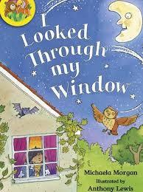  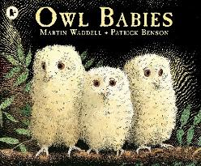  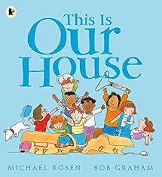  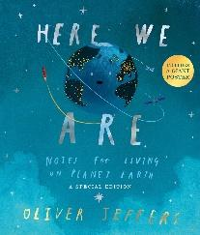 |  |  |  | Night Time Stories  Autumn 2 2021  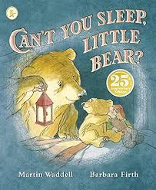  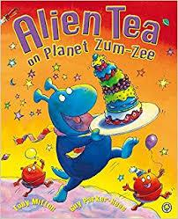  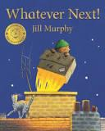  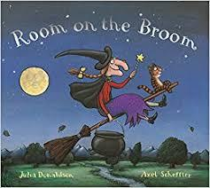
Entry Point | Explore and Experience |  |  |  |  |  | Exit Point
Settling into school | Tour of school  Story by lanternlight  Send balloon into space with message |  |  |  |  |  | Alien visit to classroom, alien tea party
Aspiration |  | Responsibility | Resilience |  | Consideration | Community
Our School Values
Last year, we worked with children, staff, parents and governors to develop our five core Beckford values, Aspiration, Responsibility, Resilience, Consideration and Community. These themes run through each of our topics.
Our topic themes are carefully selected to expose all children to a wide range of ideas, language, learning opportunities and experiences. This enables them to make connections in their learning as well as providing a springboard to ignite their imagination, curiosity and creativity.
Every unique child will access these learning opportunities at their own level and make progress from their own starting points. Key thinking and learning skills linking to the prime areas of learning are developed through all topics.
Reception Topic Map – Autumn Term
PERSONAL, SOCIAL, EMOTONAL DEVELOPMENT | COMMUNICATION AND LANGUAGE |  | PHYSICAL DEVELOPMENT
Settling in.  Becoming familiar with class routines. Exploring our new setting; tour of the school.  Learning names and getting to know each other through Circle Time and class games.  Introducing the Golden Rules through stories and role-play.  Introducing the Zones of Regulation through story characters.  Talking about ourselves and our families.  Beginning to explore our West Hampstead Primary School values: community, consideration | Encouraging talk through quality conversations play and in-class discussions.  Listening games.  Introducing Talk Partners.  Introducing our Visual Timetable and understanding what happens now and next.  Introduce Helicopter Stories (creating own stories orally).  Begin to build a repertoire of songs and rhymes.  Retelling familiar stories.  Establishing good listening behaviour using prompts and visuals. |  | Fine-motor skills:  - Introducing whole-class teaching of correct letter formation movements (during phonics sessions and throughout the setting)  - Finger Gym activities.  - Activities to develop scissor skills, pencil grip and control.  Gross-motor skills:  - Weekly PE sessions with coaches.  - Encouraging a range of movements using large equipment outside.  - Introducing rules for moving around safely and handling equipment with care.
LITERACY | Reception – Autumn Topics |  | MATHEMATICS:
Reading:  - Using the Book Corner.  - Sharing rhymes.  - Story Time.  - Adults modelling reading for different purposes.  - Introduce Home Reading.  - Introduce Phonics scheme (building on Phase 1 and introducing Phase 2)  Writing:  - Helicopter stories (creating own stories orally)  - Name writing.  - Learning correct letter formation in Phonics sessions.  - Writing opportunities through play eg. Shopping lists, invitations, labels.  - Writing opportunities linked to core texts. | Autumn 1: Me and My Little World  Autumn 2: Night Time Stories |  | Classifying objects and comparing sets  Describing, creating, and continuing patterns  Understanding numbers within 6 in depth through stories, games, songs and exploring a range of ways to represent quantities.  Addition and subtraction within 6.  Measures: capacity, weight and length – developing vocabulary to make simple comparisons.  Shape and sorting.
EXPRESSIVE ARTS AND DESIGN |  | UNDERSTANDING THE WORLD
Family portraits and self-portraits.  Becoming familiar with creative materials in the classroom and our workshop approach to enable children to build on their own interests and ideas.  Miss Schaffer’s weekly art lessons:  Books:  Mixed by Arree Chung  Mixing paint, using a paint brush, washing a paint brush,  Primary and secondary colours  Books:  The Day the Crayons Quit by Drew Daywalt  Harold and his purple crayon by Crockett Johnson  Exploring line and mark making.  Music:  Charanga music programme  Unit 1 Cross Curricular/topic-based focus: Me!  Unit 2 Cross Curricular/topic-based focus: My Stories |  | People who help us -getting to know adults at school.  Becoming familiar with the school setting and going on a tour.  Using Google Earth to find West Hampstead School.  Celebrating our diverse community, getting to know each other, finding out about similarities and differences between each other and our families.  Talking about celebrations.  Day and Night; animals. All about owls!  Exploring seasonal change: Autumn and Winter.

